# Changes from planning stage

## Changes to use cases

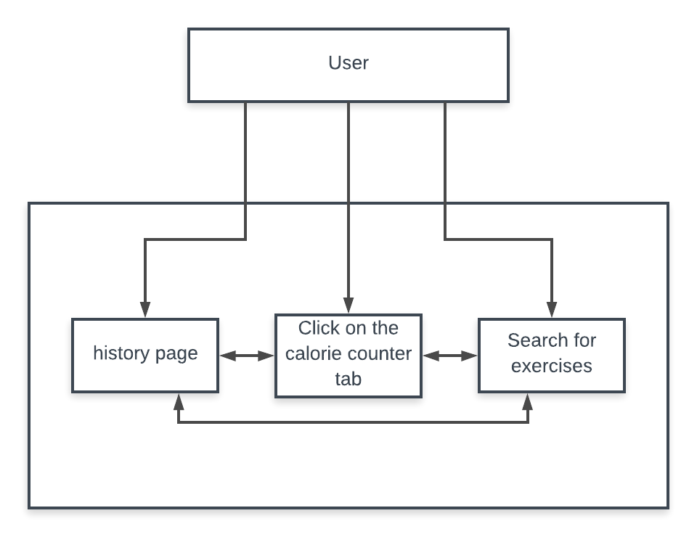

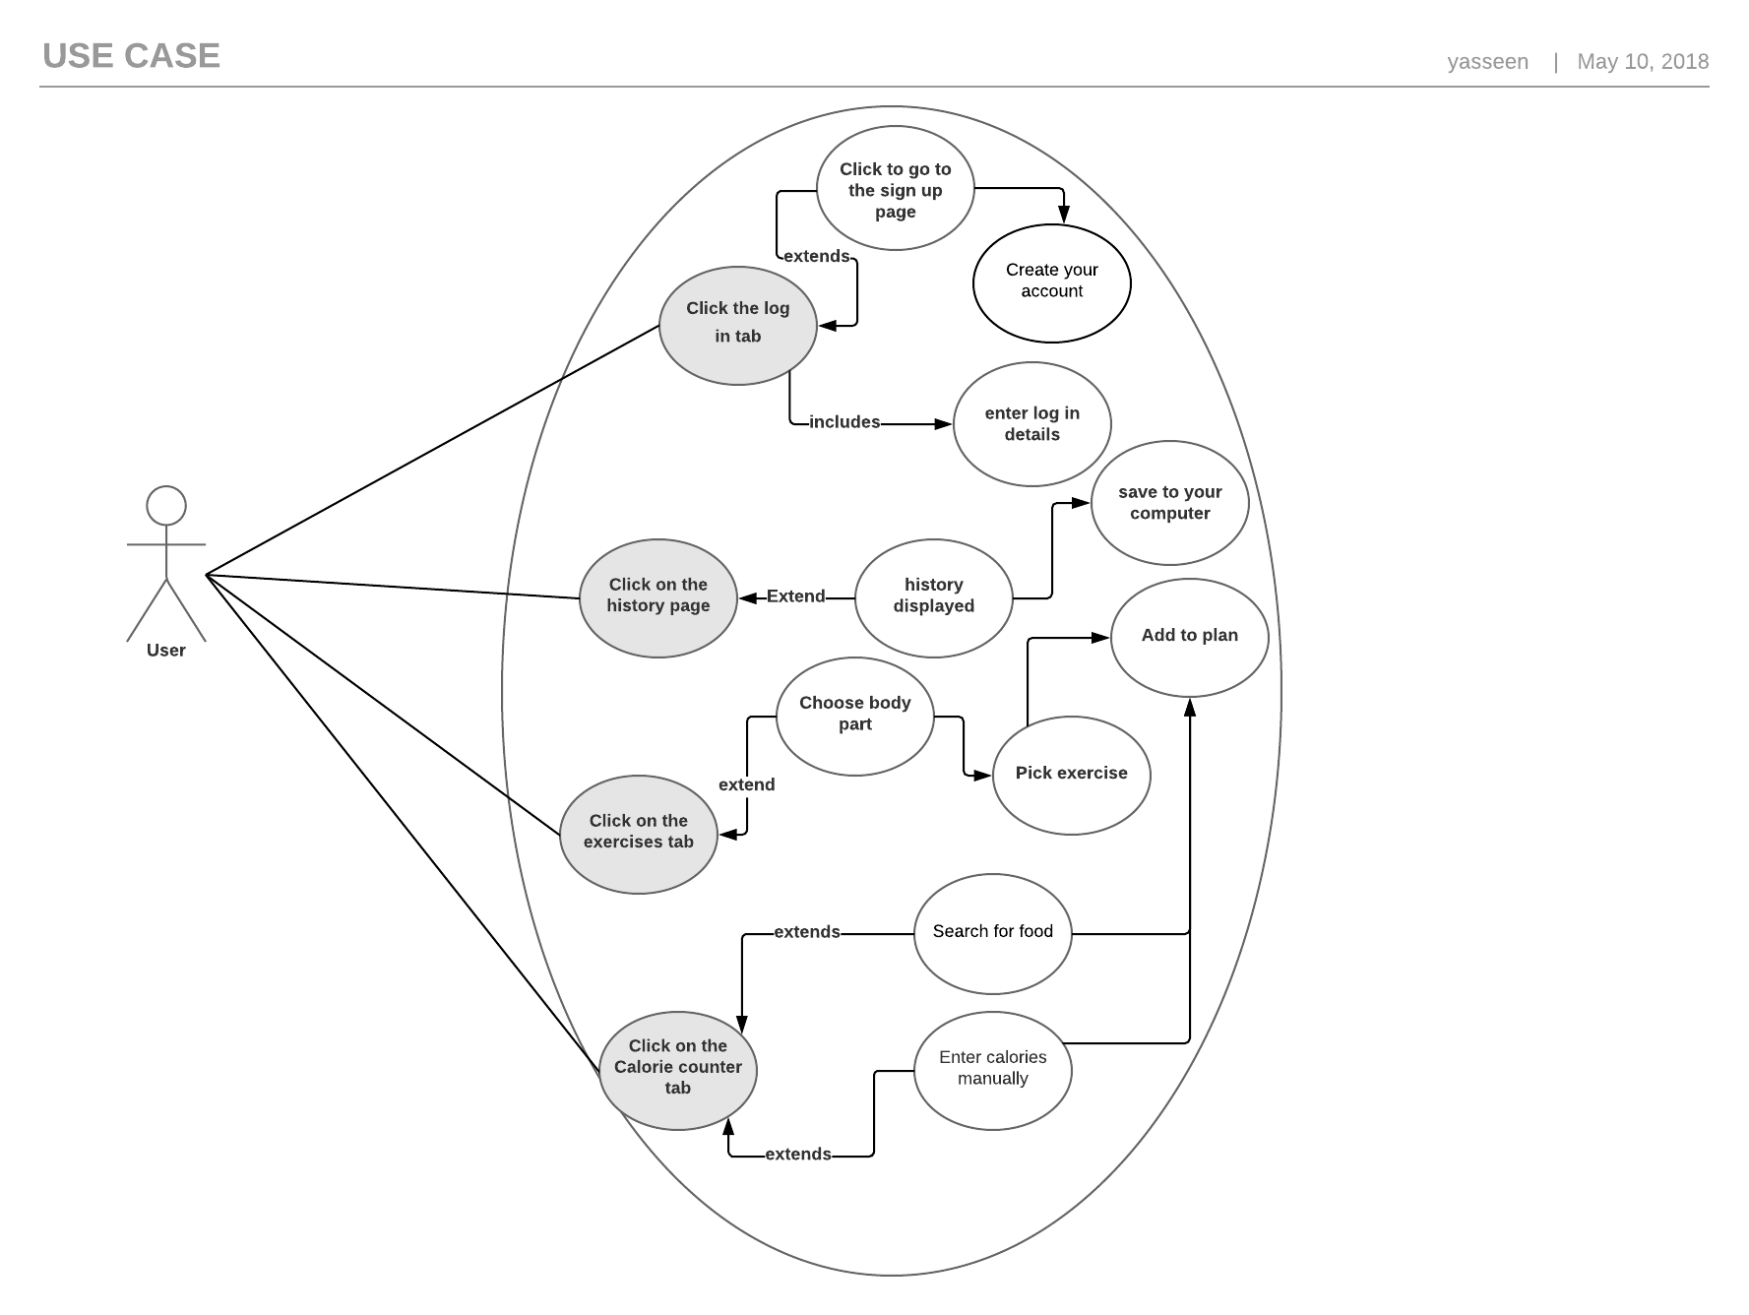

The main change here is that I had changed the diet plans with the history page. The main reason behind this was because I felt like it would work better with the site. The thought behind it is because the user would probably prefer to keep track of their diet and what they have eaten rather than to just view a couple of plans online.

## Changes to designs

Exercises design

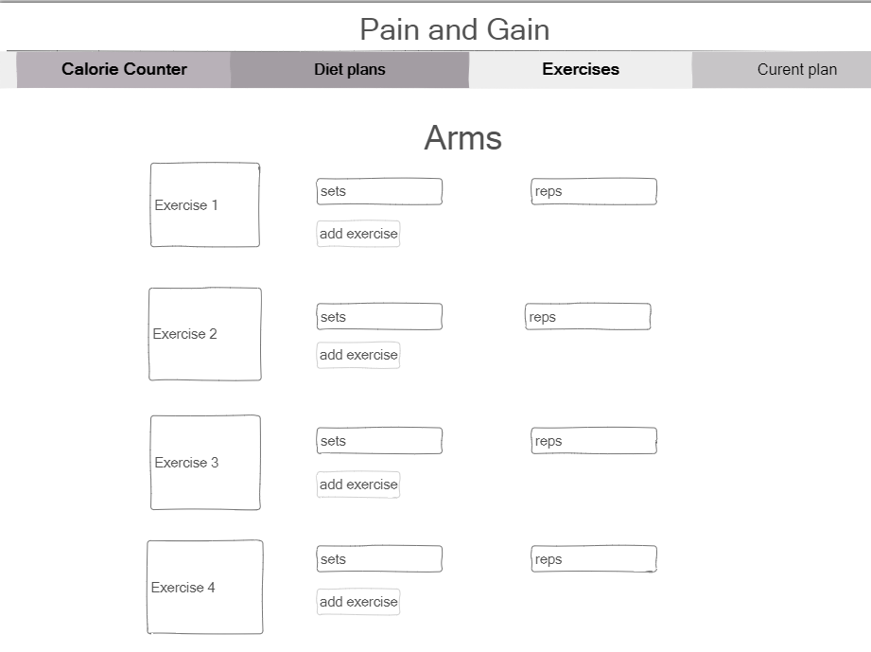

In this case there wasn’t anything major that was changed. It was mainly just a design change which made it a lot easier for the user to access and use without being too confused.

## Current plan change

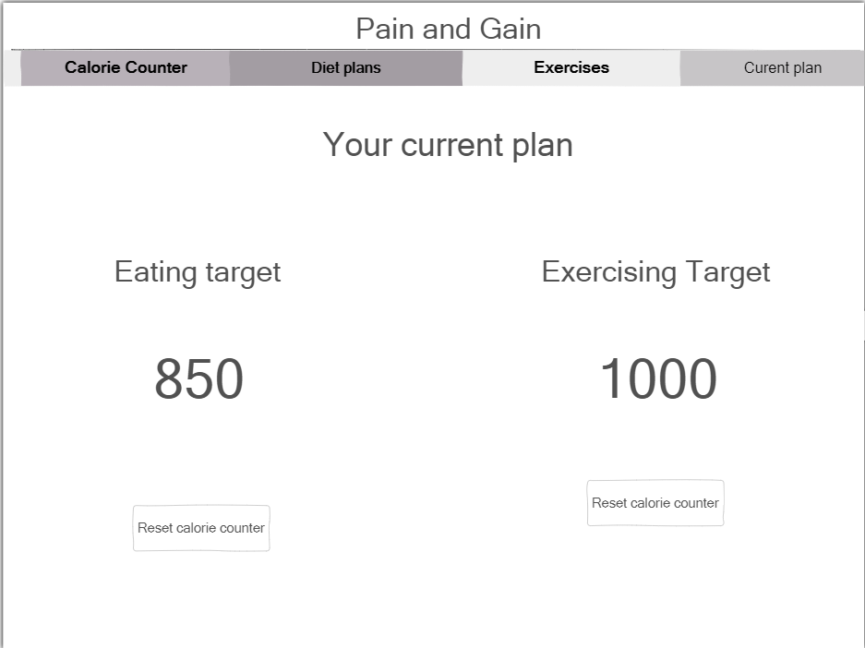

This was also not a major change, it was done to make it look better visually and to make it clearer for the user which counter was for which target.